HERMES AGENT MINI RESEARCH ASSISTANT

1. Objective
The objective of this task was to research the official Hermes Agent from Nous Research and create a small working sample using the actual Hermes repository, rather than building a separate unrelated chatbot application.
For this evaluation, I created a Hermes Agent Mini Research Assistant demo using Google Colab as a safe Linux runtime. This allowed me to:
- work with the real Hermes Agent repository
- avoid heavy local installation on Windows
- validate installation and configuration
- run a real Hermes CLI sample
- capture screenshots for internal documentation and demo purposes

2. Official Reference
Official repository used:
- GitHub Repository: NousResearch/hermes-agent GitHub Repository
Official documentation used:
- Hermes Agent Documentation: Hermes Agent Documentation
Key documentation references:
- Installation Guide: Installation Guide
Quickstart Guide: Quickstart Guide
- Architecture Guide: Architecture Guide
- Skills System Guide: Skills System Guide
- FAQ / Troubleshooting: FAQ & Troubleshooting

3. What Hermes Agent Is
Hermes Agent is an open-source AI agent framework from Nous Research designed to act as a long-running, tool-using AI assistant rather than a simple prompt-response chatbot.
The official project positions Hermes as:
“The agent that grows with you.”
In practical terms, Hermes is:
- a CLI-first AI agent
- capable of tool calling
- able to use terminal commands, file operations, browser actions, code execution, and research workflows
- able to retain useful context through memory
- able to store reusable procedures through skills
- able to run in CLI, and also connect to messaging platforms such as Telegram, Discord, Slack, WhatsApp, Signal, and Email through a built-in gateway

4. Purpose of the Hermes Agent
The purpose of Hermes Agent is to provide a more practical and persistent AI teammate / AI operator experience rather than a one-off chat interface.
Typical use cases include:
- terminal-based coding assistance
- file reading/editing workflows
- local development support
- research tasks
- debugging and troubleshooting
- automation via cron / scheduled jobs
- multi-platform assistant bots (Telegram, Discord, etc.)
- reusable workflow execution through skills
- memory across sessions
- agentic workflows that combine tools + LLM reasoning
According to the official docs and site, Hermes supports:
- Platforms: CLI, Telegram, Discord, Slack, WhatsApp, Signal, Email
- Environments: local machine, Docker, SSH, Modal, Daytona, Singularity
- Skills: bundled + community + agent-created skills
- Research workflows: batch trajectory generation, RL integration, export paths for training workflows

5. Why Hermes Agent Is Getting Attention / Why It Is “Famous”
Hermes Agent is getting strong attention because it is positioned differently from many typical AI chat tools.
Main reasons it is getting traction:
1) It is not just a chatbot
Hermes is designed as an agent system, not merely a text interface.
It can:
- use tools
- run commands
- inspect files
- execute code
- browse
- coordinate tasks
This makes it much closer to an AI operator than a simple assistant.

2) “The agent that grows with you”
This is one of the most distinctive ideas.
Hermes emphasizes:
- memory (facts / persistent context)
- skills (procedures / reusable workflows)
This means the system can become more useful over time instead of acting like a blank slate every session. The FAQ explicitly distinguishes memory (facts) from skills (procedures), and the Skills docs explain how skills are stored and reused.

3) Skills system is unusually strong
Hermes has a built-in skills system that acts like reusable operational knowledge.
Skills are:
- markdown-based
- agent-loadable on demand
- installable from hubs / GitHub
- creatable by the agent itself after solving non-trivial workflows
This is a major differentiator because it gives Hermes a reusable procedural layer, not just chat history.

4) Multi-platform from one core agent
Hermes can run:
- locally in CLI
- or through a shared gateway on messaging platforms
That means the same agent can become:
- a personal terminal assistant
- a team Telegram bot
- a shared internal support bot
- an automation agent
This makes it useful beyond developer-only CLI use.

5) Model/provider flexibility
Hermes is not tightly locked to a single model vendor.
The official docs show support for:
- OpenRouter
- Nous Portal
- OpenAI Codex
- custom OpenAI-compatible endpoints
- and local/self-hosted compatible setups (e.g., Ollama / local OpenAI-compatible APIs via config)
This makes it attractive for:
- experimentation
- cost control
- enterprise flexibility
- local/private deployments

6. How Hermes Agent Is Different from Other AI Tools / Agents
Hermes vs regular chatbot tools
A regular chatbot usually:
- responds to prompts
- may have temporary session memory
- often lacks persistent operational knowledge
- may not have rich local tool access
Hermes, by contrast:
- is tool-first
- is CLI-native
- can work with terminal + files + code + browser
- supports persistent memory
- supports skills (reusable procedures)
- can become a multi-platform assistant
- can run across different environments

Key differences of Hermes Agent
1) Memory vs Skills
Hermes separates:
- Memory = facts about the user/project/preferences
- Skills = reusable “how-to” procedures
This is a strong design difference from many agents that only store vectorized conversation snippets. The Hermes FAQ explicitly describes this distinction.

2) Agent-created skills
Hermes can create and manage skills itself after solving tasks.
This means:
- when it discovers a useful workflow
- or recovers from errors
- or completes a complex task
…it can save that process as a reusable skill for later. The Skills docs describe this as part of Hermes’ procedural memory model.

3) Multi-environment support
Hermes is designed to run in more than one place:
- local terminal
- Docker
- SSH
- Modal
- Singularity
- server/VPS messaging gateway
This makes it more deployment-flexible than many single-interface assistants.

4) Built for ongoing workflows, not just single prompts
Hermes is better suited to:
- repeated operational tasks
- development workflows
- internal tooling
- automation
- persistent assistant behaviour
This is why the project is more accurately described as an AI teammate / AI agent framework than a chatbot.

7. High-Level Architecture / Overall Brief
Based on the official architecture docs, Hermes Agent has a structured internal architecture.
Important components include:
- run_agent.py → core conversation loop / main agent logic
- cli.py → interactive CLI
- model_tools.py → tool orchestration
- toolsets.py → tool groupings and presets
- hermes_state.py → session storage / searchable history
- hermes_cli/ → CLI command implementations and dispatch
- agent/ → internal modules such as:
  - prompt building
  - context compression
  - model metadata
  - display / progress
  - trajectory handling
Practical interpretation:
Hermes is built as:
- a real agent runtime
- with tool dispatch
- session persistence
- config management
- CLI commands
- plugin/skills capability
- and provider abstraction

8. Why I Used Google Colab for This Task
I used Google Colab instead of a local Windows setup because:
- my local Windows system is storage-constrained
- Hermes is primarily designed for Linux / macOS / WSL2
- the official installation docs explicitly note that native Windows is not supported, and recommend WSL2 for Windows users
- I wanted a safe, temporary Linux environment to:
  - clone the real repo
  - install Hermes from source
  - run setup
  - avoid local WSL or heavy system changes

9. Installation Approach Used in This Demo
Instead of the one-line installer, I used a manual source-based setup because it is better for:
- transparency
- debugging
- proving the actual repo structure and installation path
The official docs state that Hermes supports a manual install path using:
- git clone --recurse-submodules
- uv
- Python 3.11 virtual environment
- uv pip install -e "." or uv pip install -e ".[all]" depending on desired extras

10. Exact Sample We Performed (Hermes Agent Mini Research Assistant)
Goal:
Use the real Hermes Agent project to perform a simple research-style task and produce a short answer.
Final successful prompt:
/content/hermes-agent/venv/bin/hermes chat -q "What is Hermes Agent? Give 3 short bullet points."
Final successful result:
Hermes returned a concise 3-bullet explanation describing:
- Hermes as a CLI-first AI coding assistant
- its modular / extensible skill and tool architecture
- its multi-platform usage through CLI and messaging gateway

11. Commands Used
11.1 Runtime check
!python --version
!uname -a
!pwd
Purpose:
Verify Linux runtime in Colab.

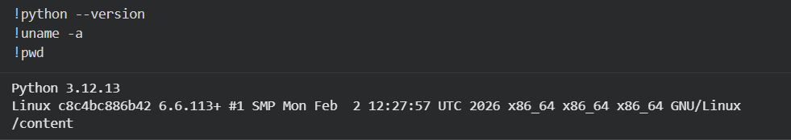
11.2 Clone official Hermes repository
!git clone --recurse-submodules https://github.com/NousResearch/hermes-agent.git
%cd /content/hermes-agent
!git submodule update --init --recursive
!ls -la
Purpose:
Clone the actual Hermes repository with required submodules.

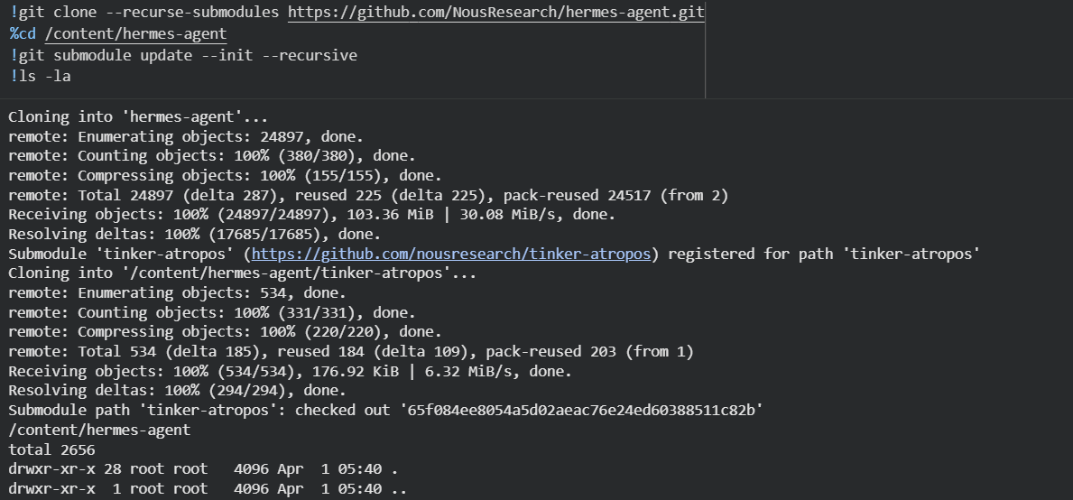
11.3 Install uv
!curl -LsSf https://astral.sh/uv/install.sh | sh
!which uv
!uv --version
Purpose:
Install the package manager used in the official manual install flow.
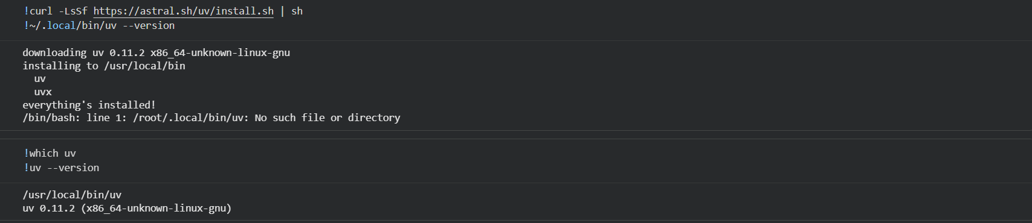

11.4 Create Python 3.11 virtual environment
!uv venv venv --python 3.11
!ls -la
Purpose:
Create the recommended Python runtime for Hermes.

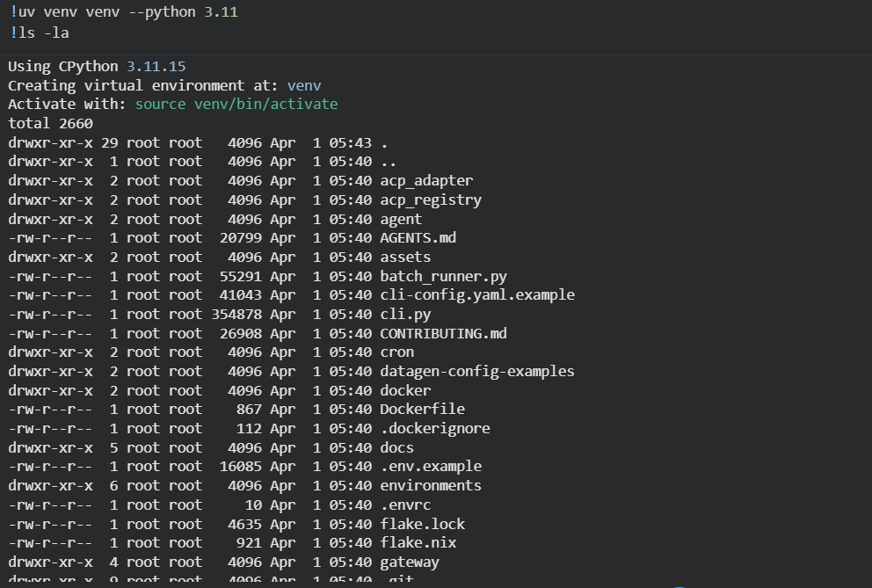

11.5 Verify venv Python
!/content/hermes-agent/venv/bin/python --version
Purpose:
Confirm the Hermes runtime uses Python 3.11.
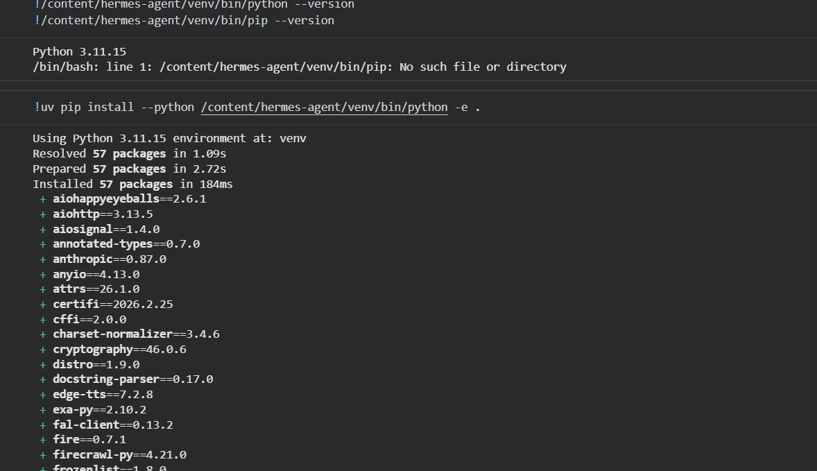

11.6 Install Hermes from source (minimal install)
!uv pip install --python /content/hermes-agent/venv/bin/python -e .
Purpose:
Install the actual Hermes package from the cloned repo into the venv.
Why minimal install?
I used the core package install instead of all optional extras.
The official docs confirm that:
- uv pip install -e "." = core agent
- uv pip install -e ".[all]" = all extras
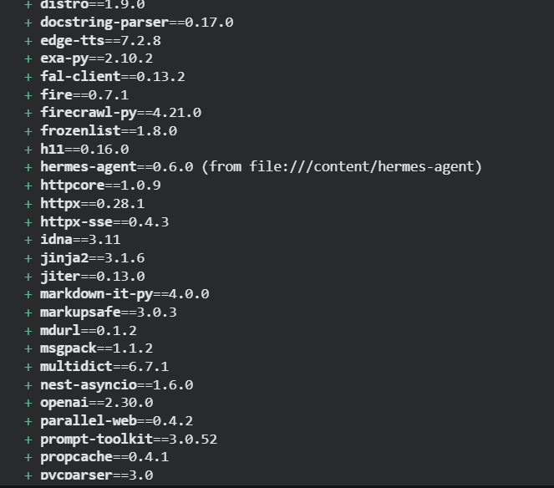

11.7 Verify Hermes CLI
!/content/hermes-agent/venv/bin/hermes --help
Purpose:
Confirm the CLI is available and inspect supported commands.
Important commands visible included:
- chat
- model
- setup
- doctor
- status
- skills
- gateway
- cron
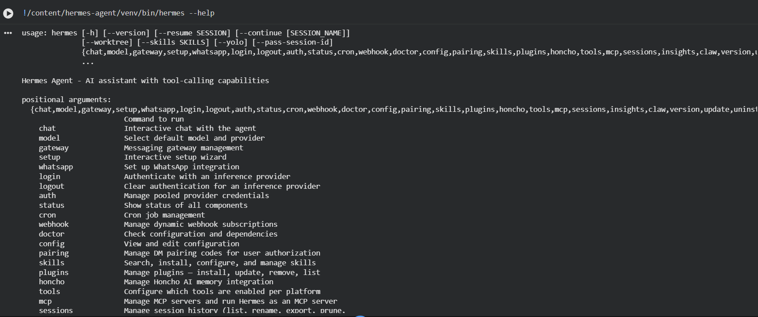

11.8 Run diagnostics (hermes doctor)
!/content/hermes-agent/venv/bin/hermes doctor
Purpose:
Pre-flight health check to detect missing configuration before running a live query.
What it showed:
- Python environment was correct
- core dependencies were installed
- ~/.hermes/.env was missing
- OpenRouter was not yet configured
- it explicitly recommended running:
  - hermes setup
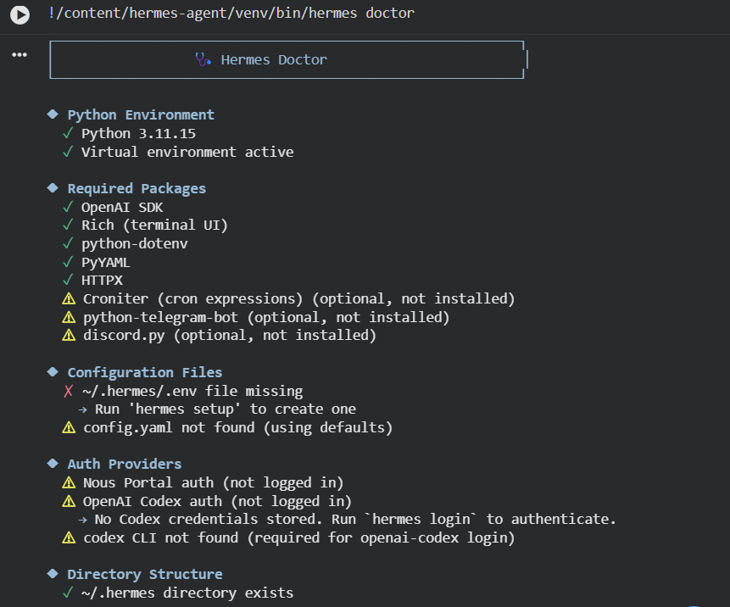

11.9 Run setup wizard
!/content/hermes-agent/venv/bin/hermes setup
Purpose:
Run the actual Hermes setup wizard.
In our setup, we configured:
- Provider: OpenRouter
- Initial model: openai/gpt-5.4-mini
- Terminal backend: local
- Messaging: skipped
- Optional API-heavy tools: skipped where unnecessary
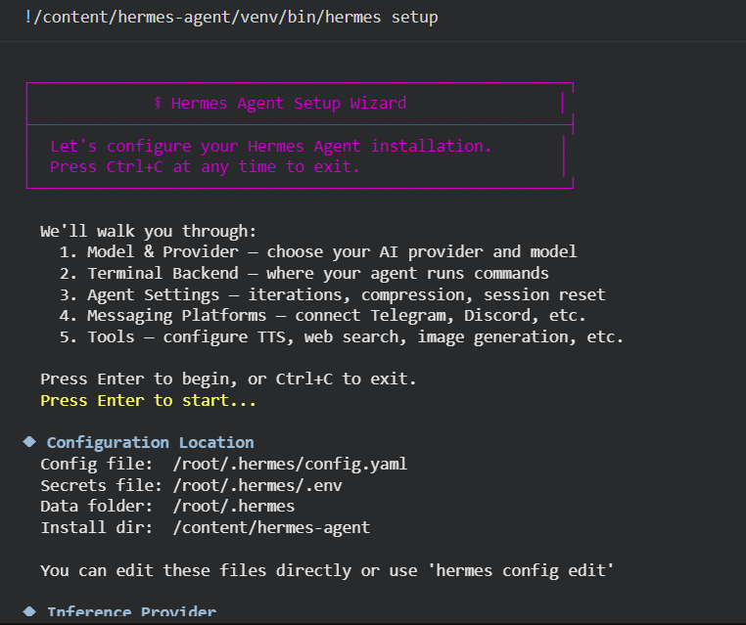

Setup Completed Successfully

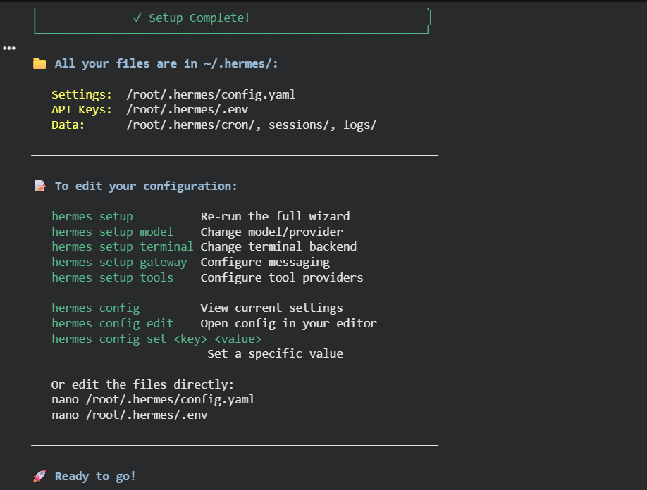

11.10 Verify runtime status
!/content/hermes-agent/venv/bin/hermes status
Purpose:
Confirm:
- .env exists
- model/provider are active
- OpenRouter key is detected
- runtime is ready
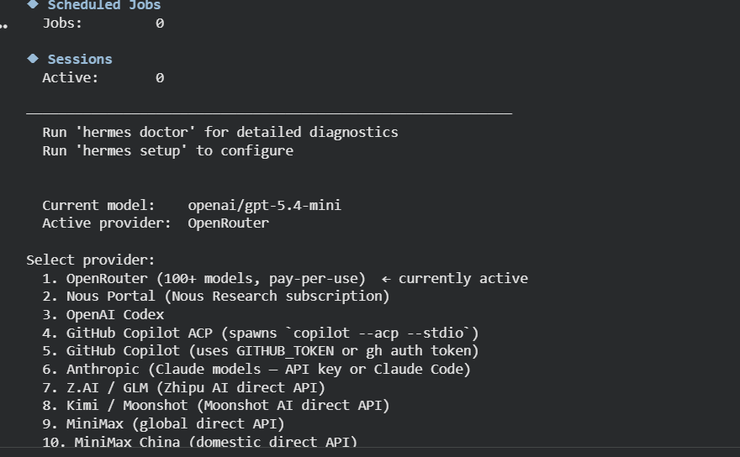

11.11 First query attempt (provider budget issue)
!/content/hermes-agent/venv/bin/hermes chat -q "Summarize what Hermes Agent is, its key features, and why it is trending in 5 bullet points."
Result:
Hermes launched correctly, but OpenRouter returned HTTP 402 because the selected model (openai/gpt-5.4-mini) requested a larger token budget than the available account credit could support.
Important interpretation:
This was a provider-side credit/token budget issue, not a Hermes installation issue. 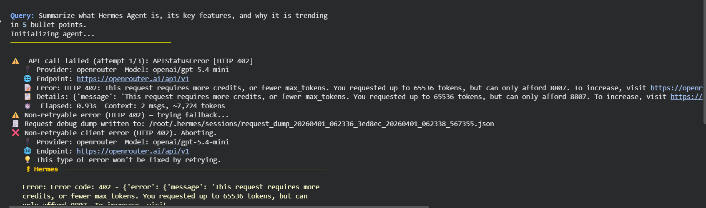

11.12 Model switch to free option
!/content/hermes-agent/venv/bin/hermes setup model
What I changed:
- Provider kept as OpenRouter
- Model changed to:
  - qwen/qwen3.6-plus-preview:free
Why:
To avoid OpenRouter credit issues and maximize successful execution.

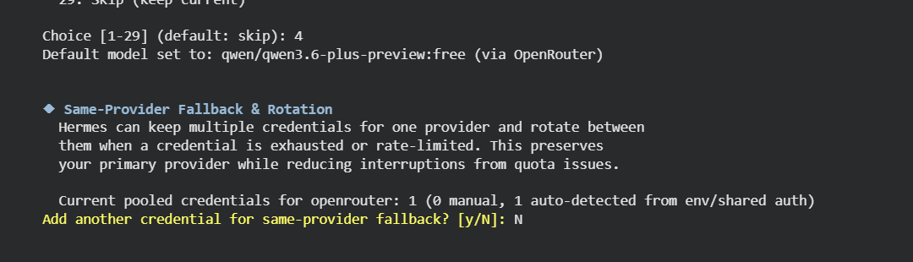

11.13 Final successful demo query
!/content/hermes-agent/venv/bin/hermes chat -q "What is Hermes Agent? Give 3 short bullet points."
Result:
Hermes successfully returned a short 3-bullet answer.
This is the final proof-of-success step.
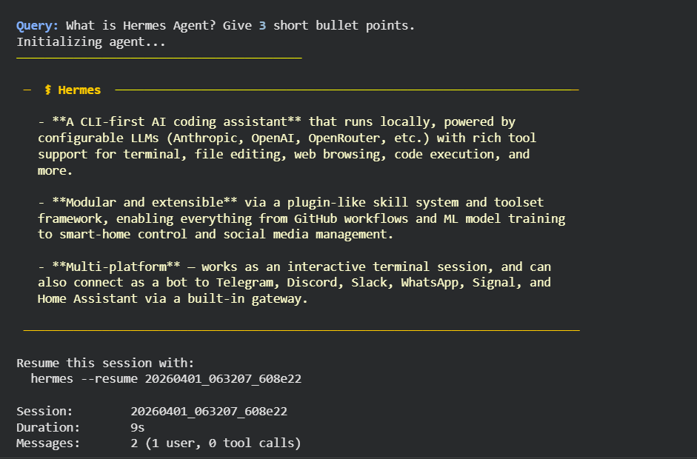

Additional Prompt Validation Using hermes chat -q

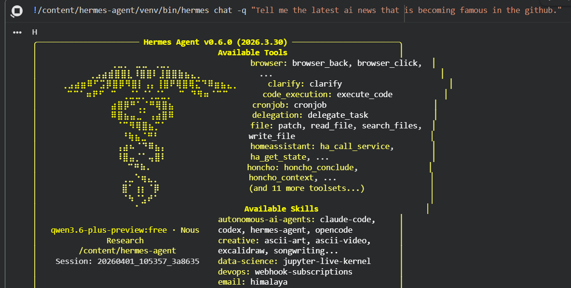

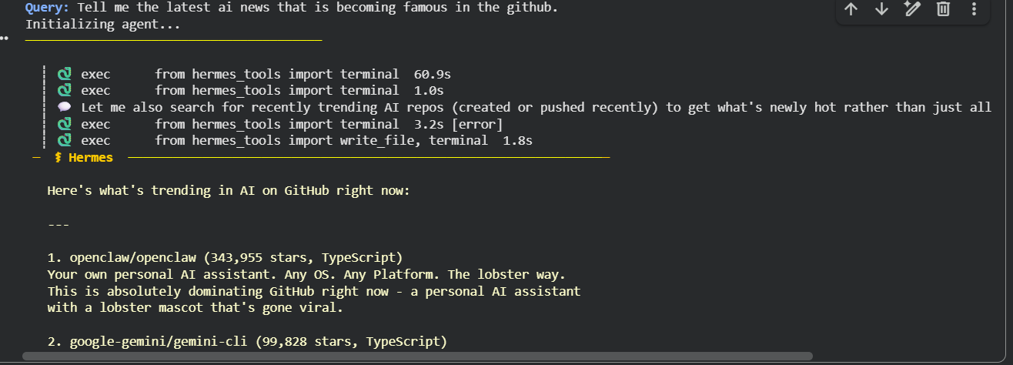
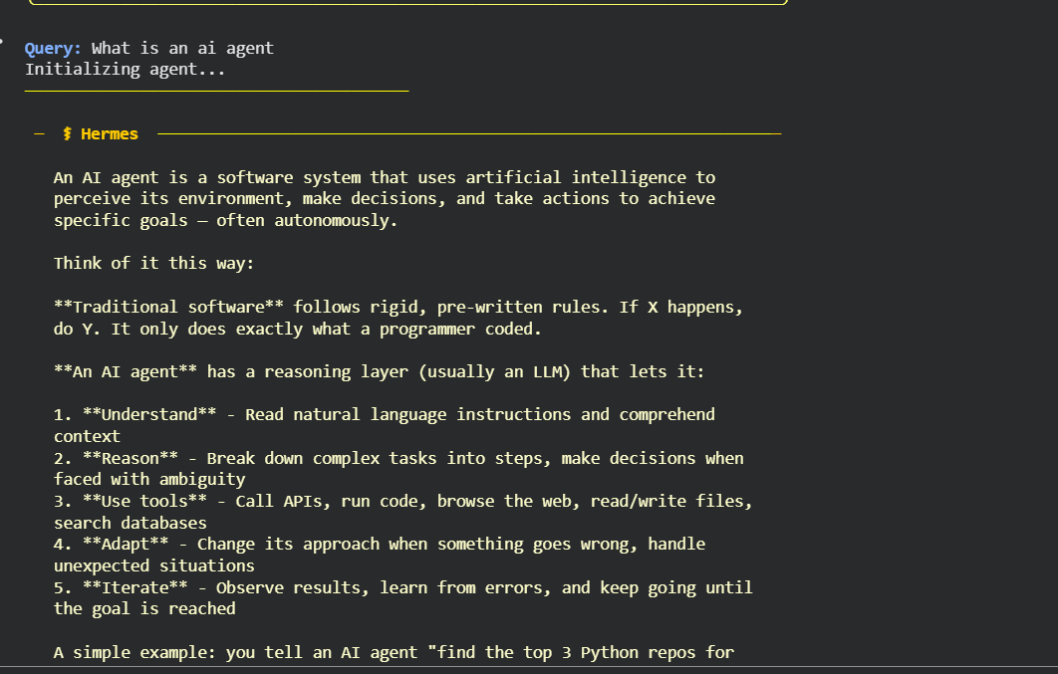
12. What Worked in This Evaluation
The following were successfully validated:
- official Hermes repository clone
- submodule initialization
- uv installation
- Python 3.11 venv creation
- Hermes source installation
- Hermes CLI availability
- hermes doctor
- hermes setup
- provider and model configuration
- hermes status
- live query execution using hermes chat -q
- successful final response using a free OpenRouter model

13. Issues / Limitations Observed
1) Native Windows is not the preferred path
Official docs recommend:
- Linux / macOS / WSL2
- not native Windows
This is why Colab was chosen for this evaluation.

2) Some optional tools need extra API keys
Examples:
- Firecrawl
- Tavily
- EXA
- FAL
- Browserbase
- Tinker
- ElevenLabs

3) Premium model selection can hit provider budget limits
The first model (openai/gpt-5.4-mini) failed because of:
- OpenRouter credit / token budget constraints
This was resolved by switching to:
- qwen/qwen3.6-plus-preview:free

4) Colab is not ideal for long interactive terminal sessions
It is excellent for:
- evaluation
- lightweight demo
But for deeper usage, a better long-term environment would be:
- WSL2
- Linux VM
- cloud instance
- Docker/server setup

14. Conclusion
This evaluation successfully confirmed that Hermes Agent can be installed, configured, and executed through its CLI workflow.
- The process validated:
- successful installation
- CLI accessibility
- environment diagnostics using hermes doctor
- provider and model configuration using hermes setup
- runtime verification using hermes status
- successful query execution using hermes chat -q
- recovery from a provider-side token budget limitation by switching to a free model
- Overall, the evaluation shows that Hermes Agent is operational, configurable, and suitable for practical tool-enabled AI agent workflows.
Final assessment:
Hermes Agent is best understood as a tool-using, persistent, multi-environment AI agent framework rather than a basic chatbot.
It is especially notable for:
- CLI-first workflow
- memory + skills architecture
- model/provider flexibility
- reusable procedural knowledge
- multi-platform deployment options
This approach provided a practical and effective way to validate the core capabilities and overall usability of Hermes Agent.

